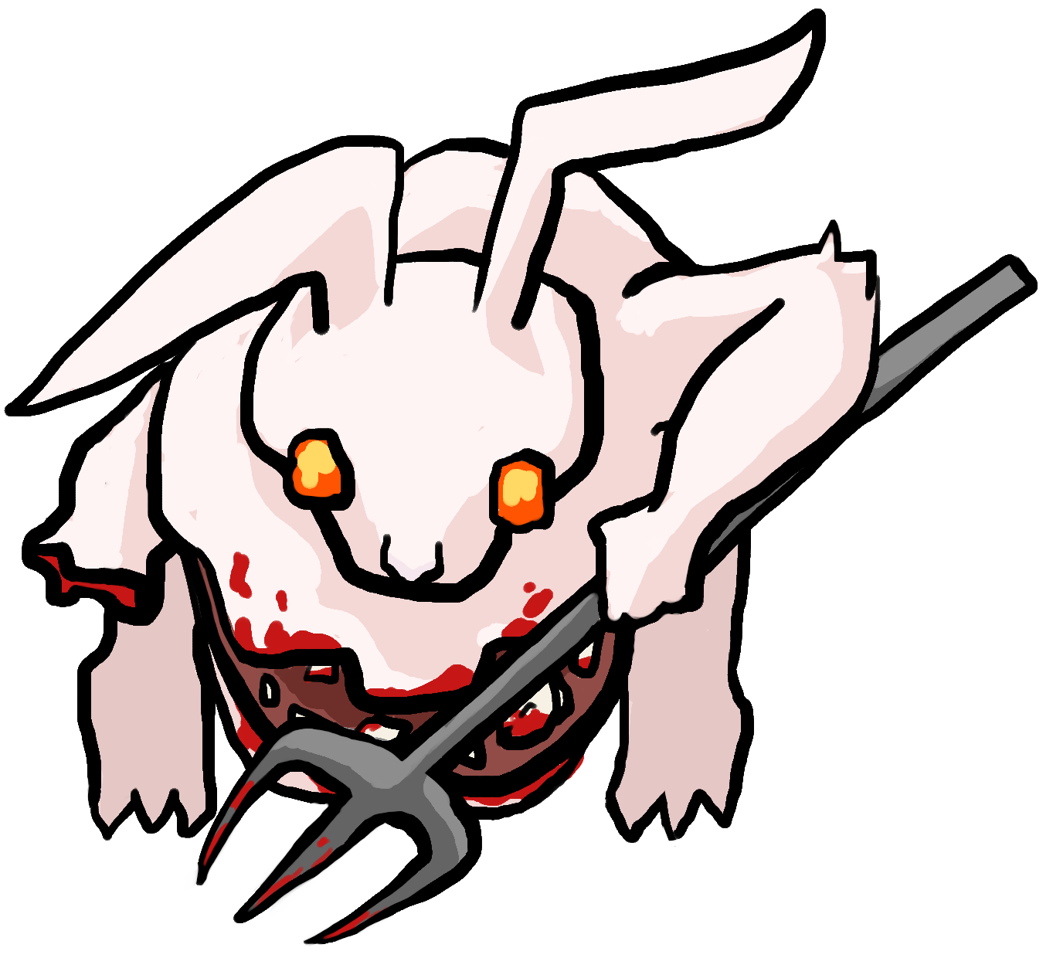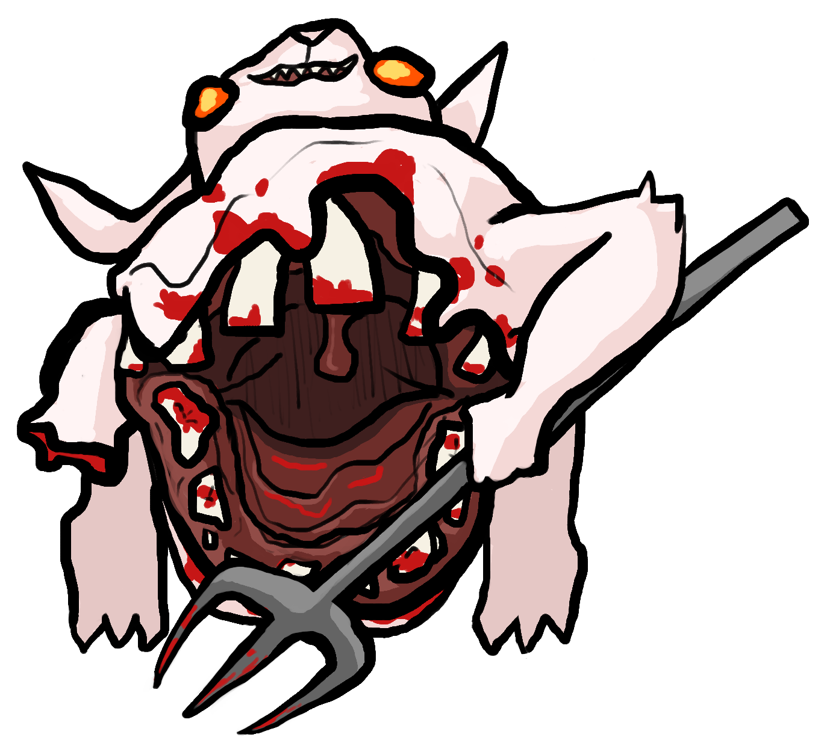**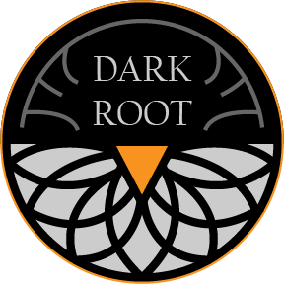Carrot Quest: The Root of Evil**

*Save Bunnyville from the Carrot Curse!*

**Mow down a variety of monstrously mutated enemies with your revolver as you investigate the source of the Carrot Curse. Navigate strange ruins from a forgotten age, make powerful allies, and find the ultimate Carrot Cannon to wipe out your foes. What dark secrets lie underneath Bunnyville?

● Terraform levels with the burrow technique to get the jump on enemies!

● Fight your way through hordes of mutated wildlife as you venture through Bunnyville.

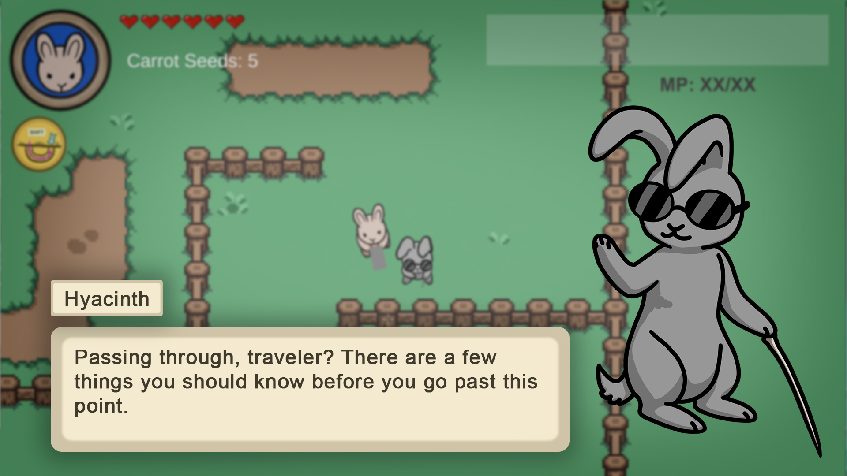**● Solve mysteries and build bonds with NPCs who have secrets of their own.